Tool Inventory
Quick Start Guide - Starting Your First Inventory
1. Create Your Inventory  Tap the + button to create your first inventory.  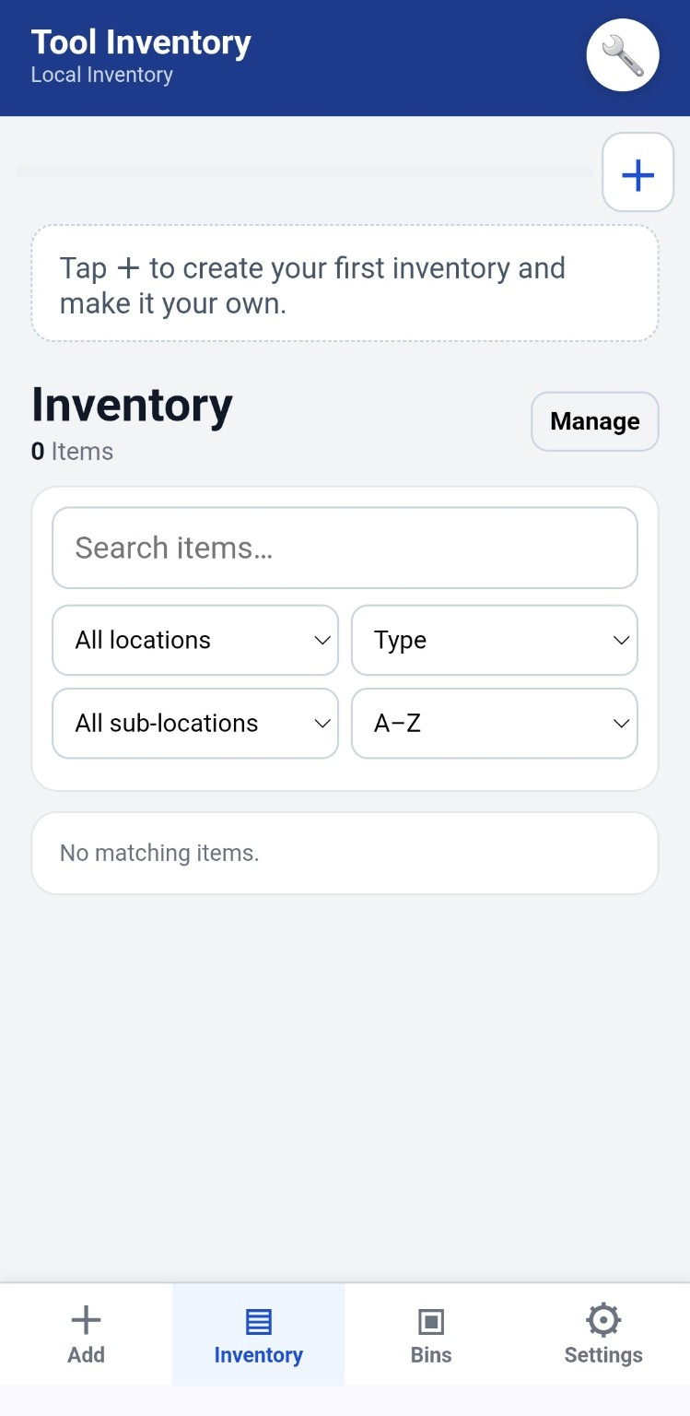 | 2. Name It  Give it a simple name such as Garage, Shop, Farm, House, or Collectibles.  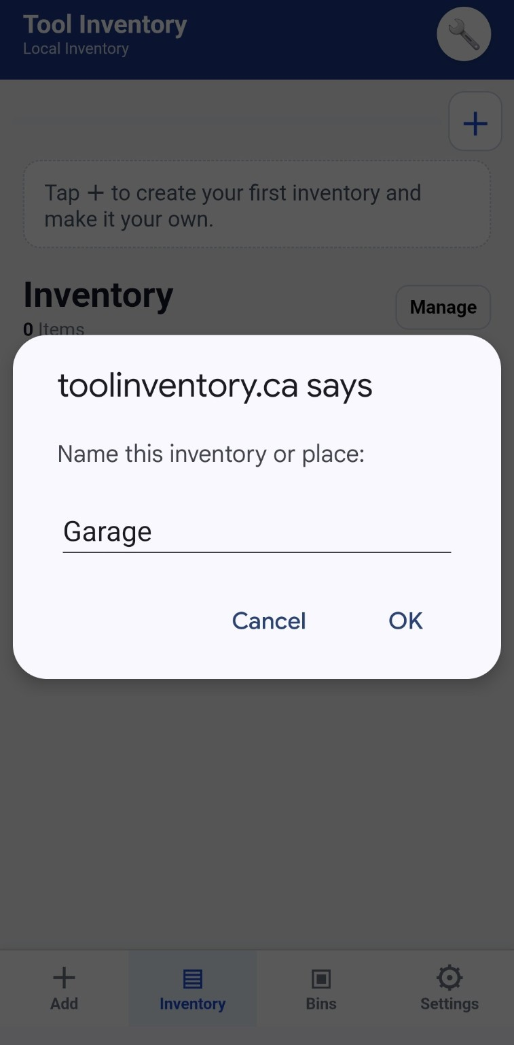
3. Manage Your Inventory  Tap Manage to choose an icon, rename the inventory, or set up locations.  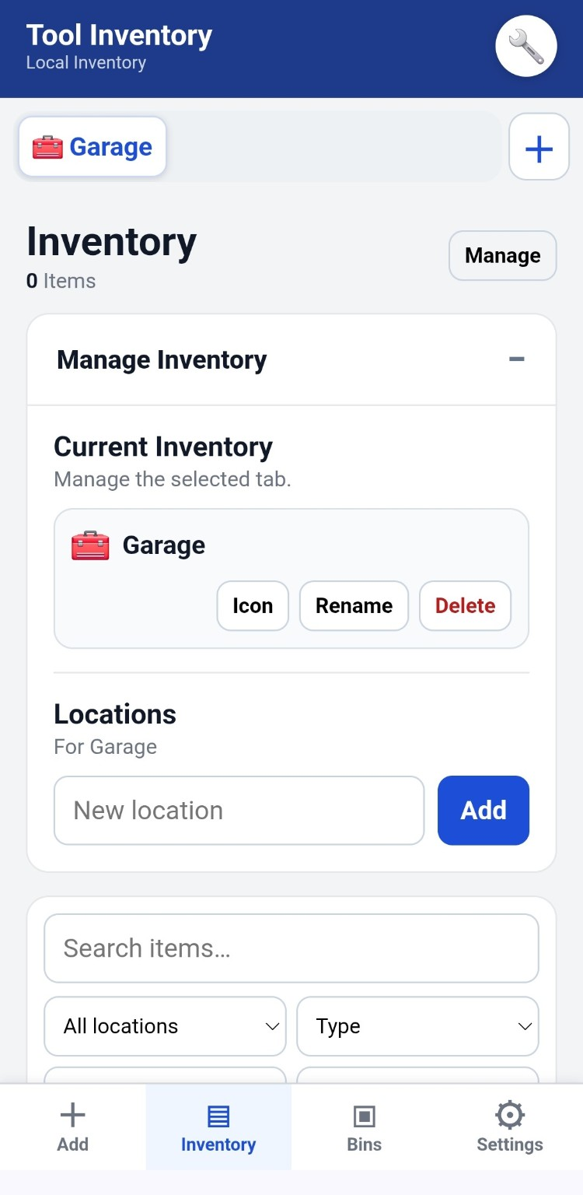 | 4. Add a Location  Enter where items are stored, such as Wall Cabinet, Main Shop, Shed, or Service Truck.  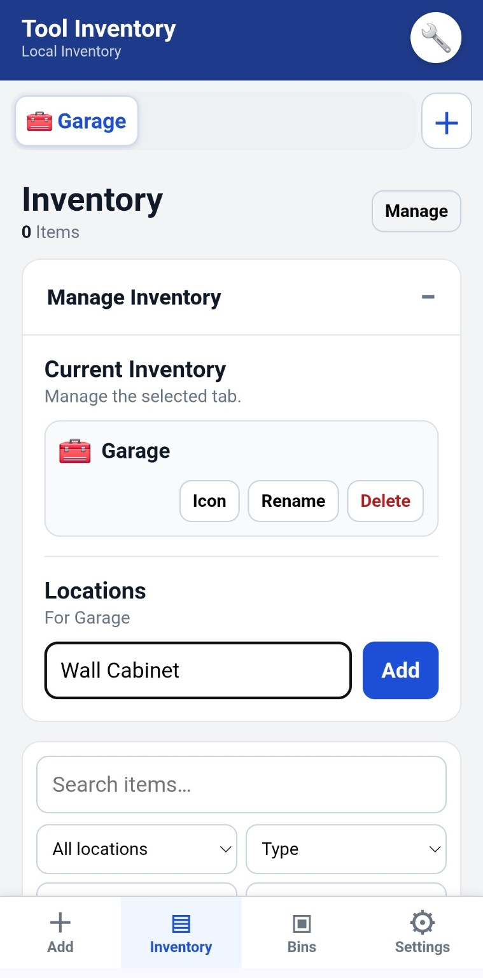

Tool Inventory
Quick Start Guide - Starting Your First Inventory
5. Check Your Location  Your new location will appear below once it is added.  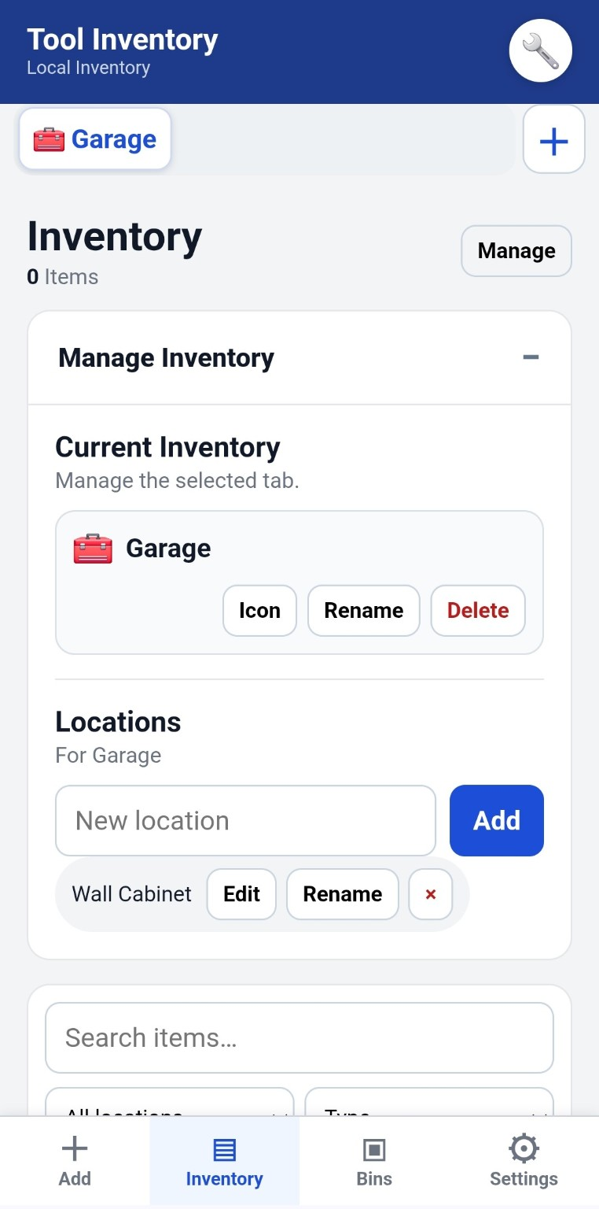 | 6. Add a Sub-location  Tap Edit beside a location to add optional Sub-locations such as drawers, shelves, cabinets or bins. Type a name and tap Add.  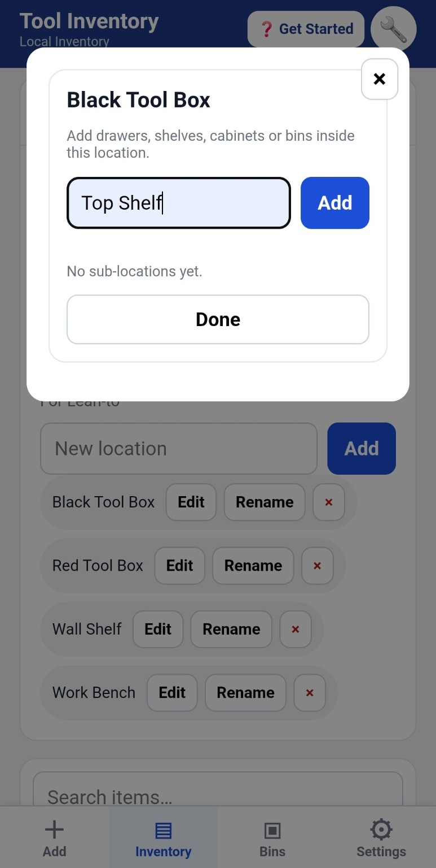
7. Add Your First Item  Enter the item name, choose a Category and Type, then select its Location.  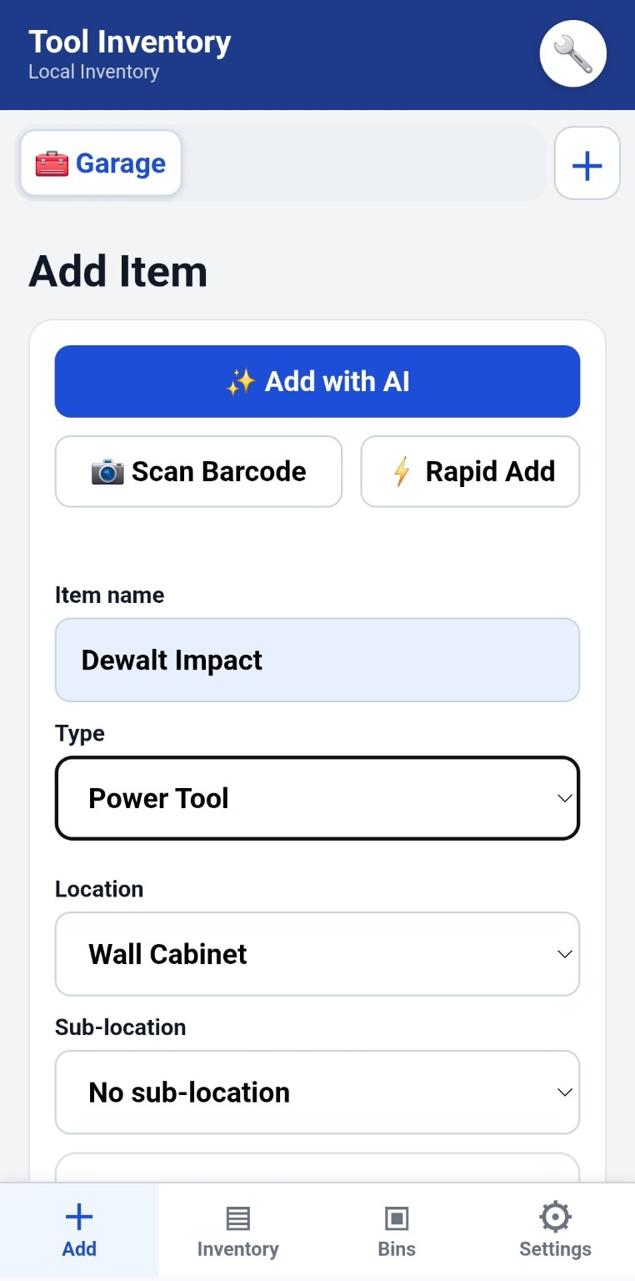 | 8. Finish & Save  Choose a Sub-location if needed, add extra details or notes, then tap Save Item.  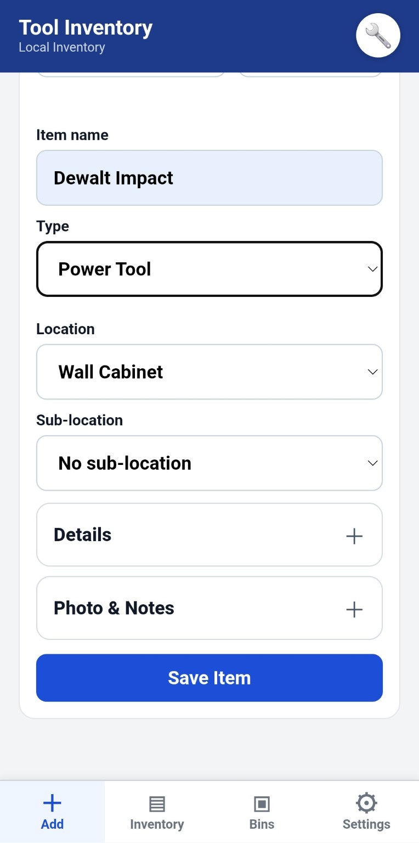
Simple. Useful. No ads.

